CLOUD COMPUTING LAB
FINAL EXAM



Submitted To:
Engr. Shoaib

Submitted By:
Komal Kashif
BSE V-A
2023-BSE-031

Q1 – AWS IAM Setup Using AWS CLI and Console Verification
- Create IAM group SoftwareEngineering using AWS CLI
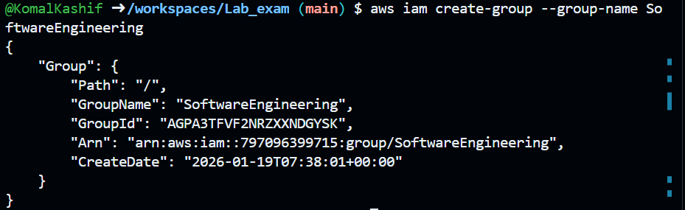
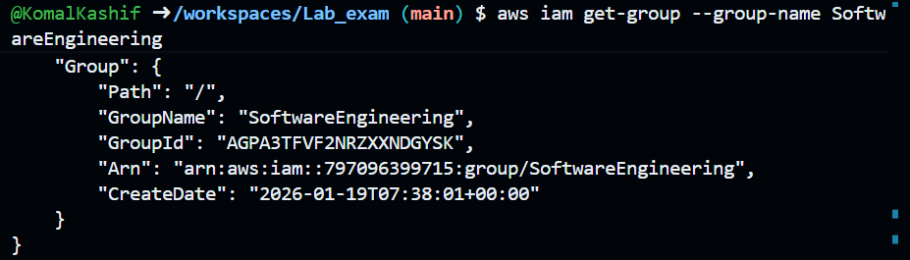
- Create IAM user (your name) and view details
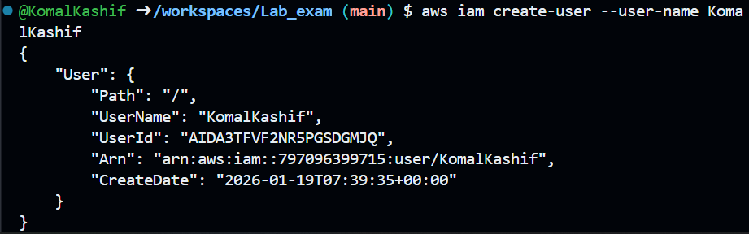
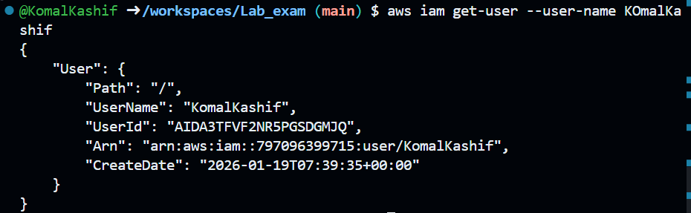
- Add the IAM user to the SoftwareEngineering group
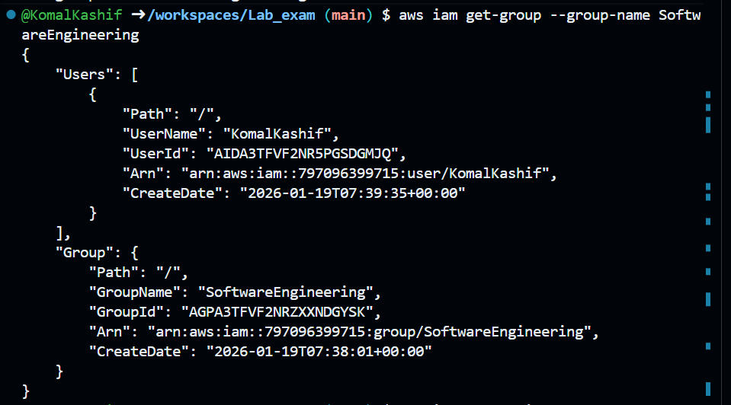
- Attach AdministratorAccess managed policy to the SoftwareEngineering group
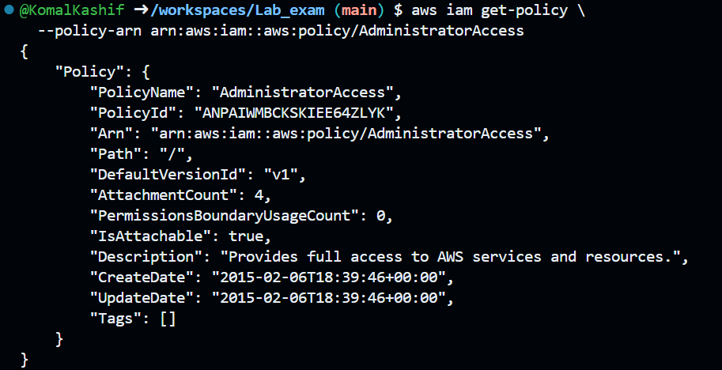
- List attached policies of the SoftwareEngineering group
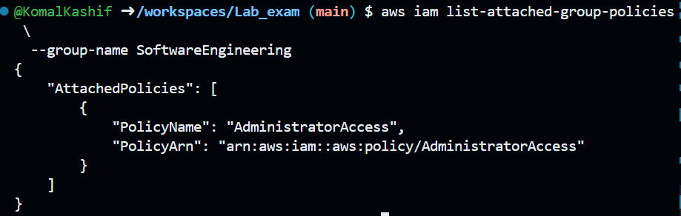
- Verify IAM configuration in AWS Management Console
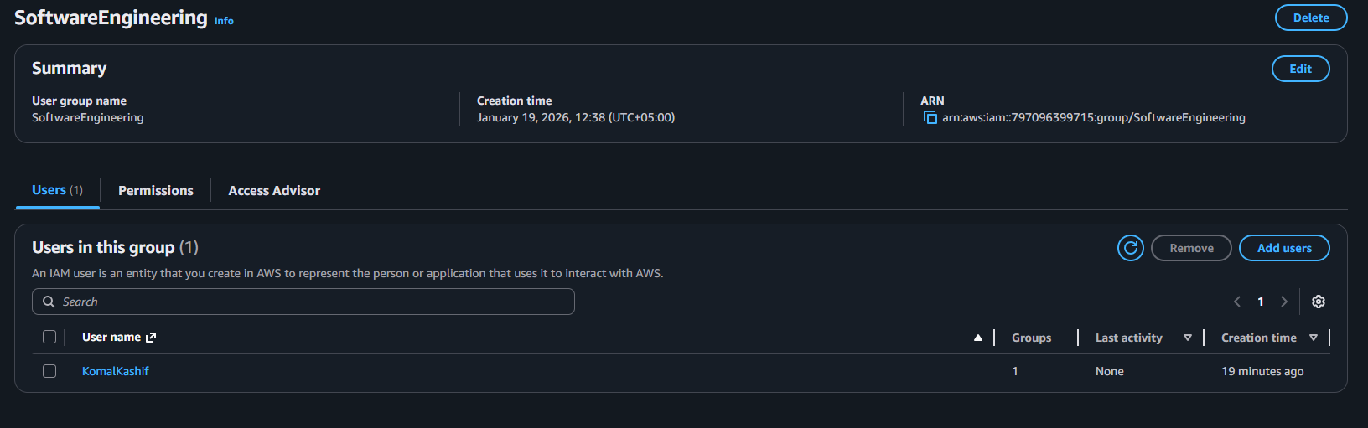
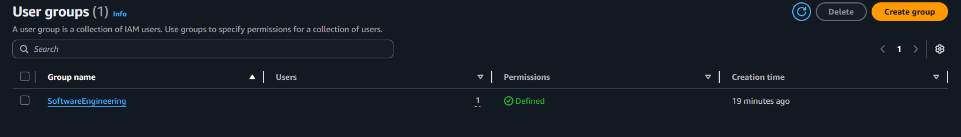
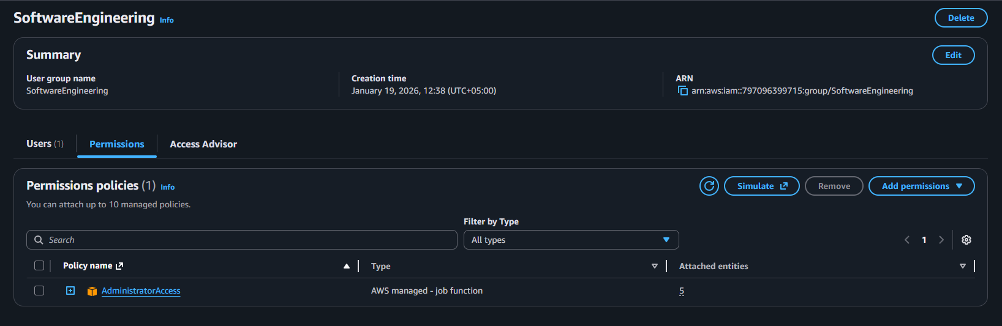
Q2 – Terraform Lab: Simple AWS Environment with Nginx over HTTPS
- Configure the AWS provider
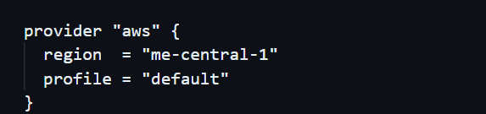
- Define input variables
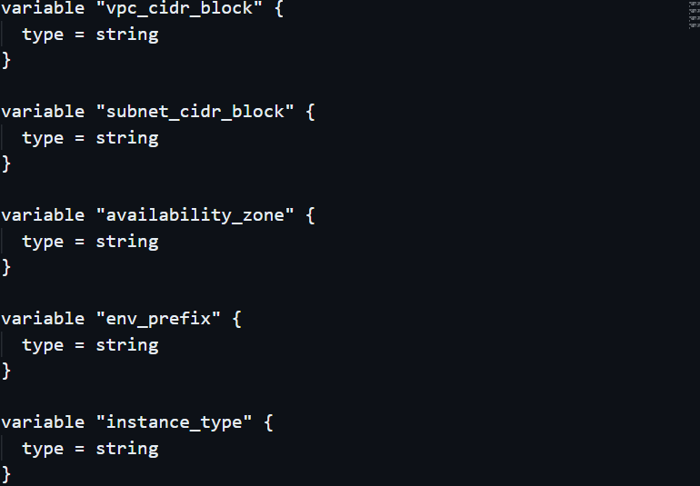
- Create VPC and subnet
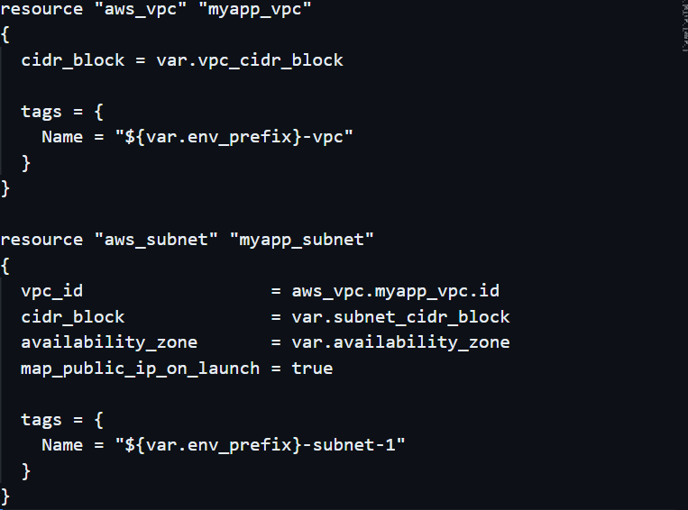
- Create Internet Gateway and configure default route table
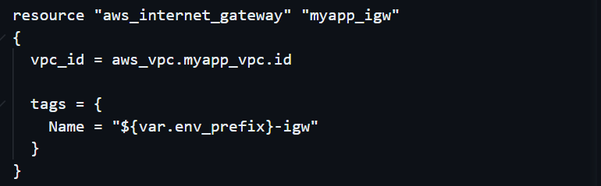
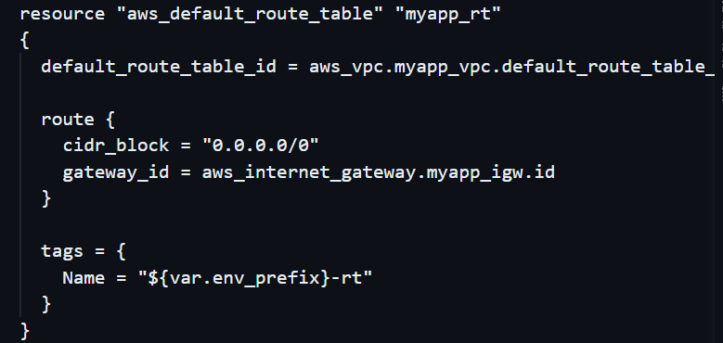
- Discover public IP and compute /32 CIDR using data + locals
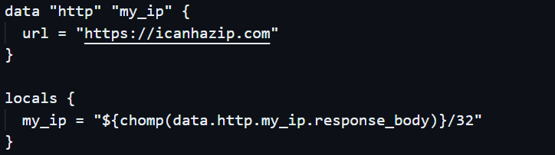

- Configure the default security group in the VPC
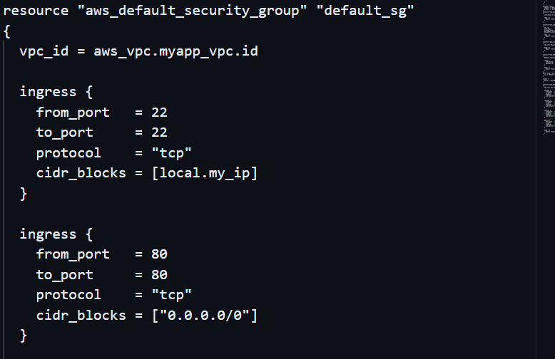
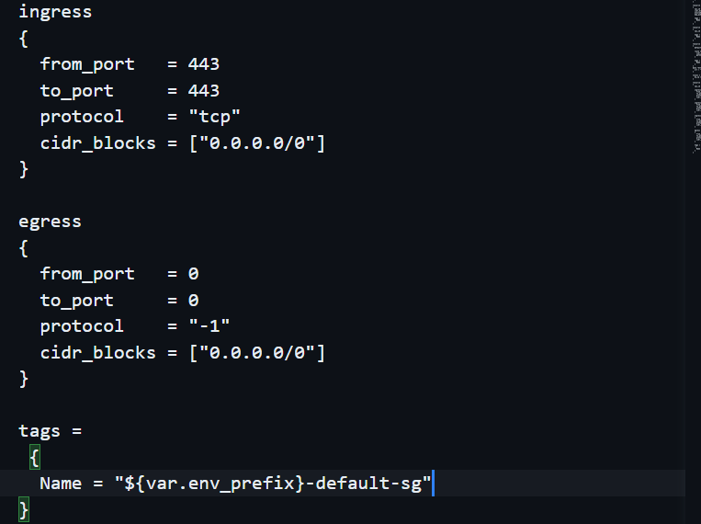
- Create an AWS key pair for SSH
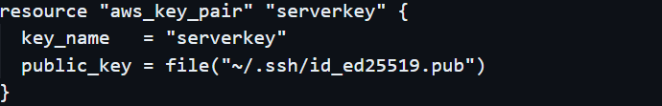

- Create the EC2 instance resource
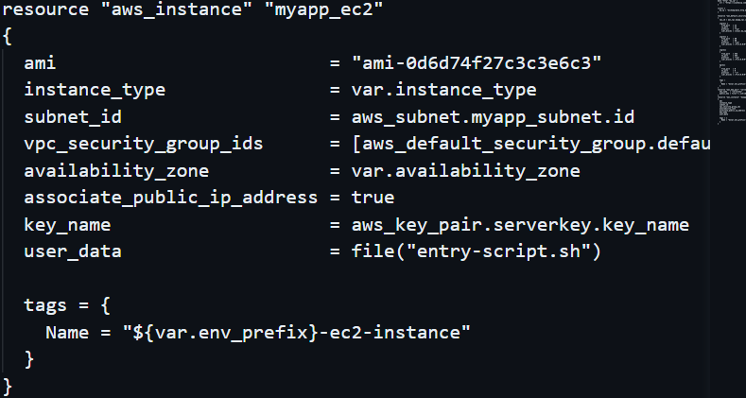

- Create entry-script.sh to configure Nginx + HTTPS
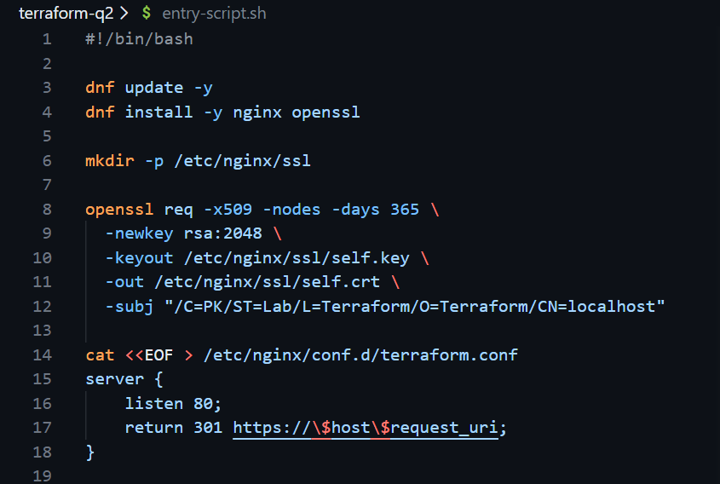
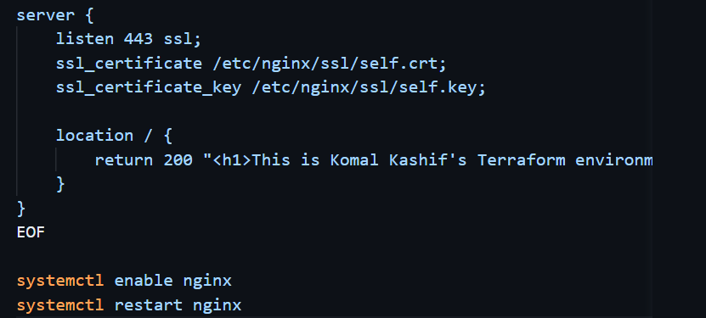
- Add Terraform output for public IP
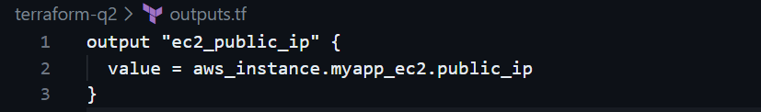
- Set variable values for apply time
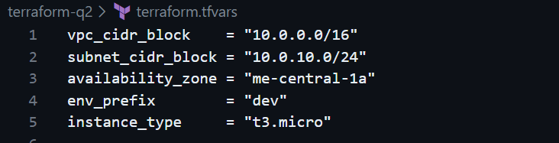
- Run Terraform commands and capture outputs

- Verify Terraform resources in AWS console
- Verify HTTPS access from browser

